Personal Portfolio

Timothy Bunt

N9408002

|  |  |  |  |  |
| --- | --- | --- | --- | --- |
| **What did you do that made a meaningful contribution to the teamwork in producing the final solution** | | **Evidence of that work (artefact)** | | **How did it fit in the team work / project work?** |
| Release 1 | | | | |
| **Created company logo** | D:\Desktop\UNI\IFB299\image.png  (using grey background so text is visible) Refer to Logo | | Complimented the sites UI whilst maintaining relevance. | |
| Studied and implemented time estimations for project | Used Three-Point Estimation to get the most accurate estimation. Used (B + 4m + W) / 6 where Best Case (B)  Most Likely Case (M)  Worst Case (W) | | Accurate project estimation and completion timeline. | |
| Researched pricing from current postal services | Refer to Pricing Research | | Enabled us to implement a reasonable pricing system for deliveries. | |
| Worked with the team to prioritise user stories | Refer to Release 1 | | Enabled us to plan out the first release to result in a highly functional site upon completion. | |
| Worked with the team to use feedback from the Client team in regards to Sprint 1 to alter our approach to development. We had been too ambitious with our initial planning which lead to us not being able to complete the projected User stories. | Refer to Release 1 Alteration | | Eased the pressure we had put on ourselves. Outlined a more manageable workload. | |
| Release 2 | | | | |
| Altered background based on client team feedback | Refer to Banner | | Client team did not like the previous background vehicle (rocket) and requested a more relevant van be used. | |
| Created a document for tracking user story completion | Refer to Tracking | | Enabled us to keep on top of our progress and easily determine the overall position we were at. | |
| Helped develop the package delivery calculator, testing integration and troubleshooting. I have pasted the broken code; line 21/22 had a duplicate ID which caused crashing. Fixed by assigning a new ID. | Refer to Calculator | | A very important part of the site, solving the issue of crashing was very important. | |
| Worked with the team on the Release 2 documentation | Refer to Release 2 | | Planned out the next stage of development | |
| Replaced front page info for cloud storage upon client request. Replaced it with a more appropriate Online Tracking. | Refer to Features | | This change showed a more appropriate feature that potential customers would feel is beneficial. | |

Banner



Tracking



Pricing Research

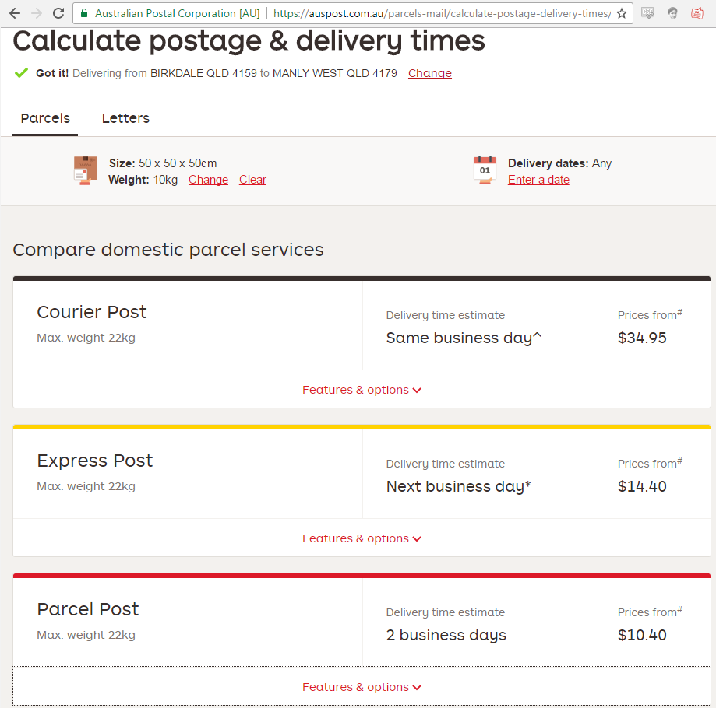

Release 1

# Release 1

Delivery date: 21/09/2016 Total Story Points: 82

The goal of this release is to have a website interface up and running. The goal is also to have most essential aspects of setting up a delivery complete such as scheduling a delivery with an account and with a payment transaction.

## Website Interface   - Sprint 1

This will provide an interface to allow customers to navigate the website easily to schedule a delivery with an account that they have registered.

|  |  |  |
| --- | --- | --- |
| **Story ID** | **Story Title** | **Story Points** |
| **S01** | User interface | 20 |
| **S05** | User Packaging | 5 |
| **S06** | Customer Account Registration | 2 |
| **S08** | Employee Accounts | 8 |
| **S16** | Estimated Costing Calculator    -  Moved to Sprint 2 | 5 |
|  | Story Point Sub-Total: | 42 |

## Package Shipping   - Sprint 2

This is where the package is organized and prepared to be delivered, the schedules and calculations of costs are made.

|  |  |  |
| --- | --- | --- |
| **Story ID** | **Story Title** | **Story Points** |
| **S02** | Customer order scheduling | 2 |
| **S07** | Customer order cancellation     -  Moving to Sprint 3 | 1 |
| **S09** | Estimation Disclaimers | 8 |
| **S28** | Customer account edit ability | 2 |
| **S16** | Phone Compatibility | 5 |
| **S4** | Customer Order Tracking | 8 |
| **S13** | Delivery Instructions | 1 |
| **S9** | Estimated Cost Calculator | 5 |
|  | Story Point Sub-Total: | 32 |

## Package tracking

This will allow the customer to easily know where their package is and let them know roughly when it will arrive.

|  |  |  |
| --- | --- | --- |
| **Story ID** | **Story Title** | **Story Points** |
| **S04** | Customer order tracking | 8 |
|  | Story Point Sub-Total: | 8 |

Release 1 Alteration

# Release 1

Delivery date: 07/09/2016 Total Story Points:

The goal of this release is to have a website interface up and running. the goal is also to have most essential aspects of setting up a delivery complete such as scheduling a delivery with an account and with a payment transaction.

## Website Interface

This will provide an interface to allow customers to navigate the website easily to schedule a delivery with an account that they have registered.

|  |  |  |
| --- | --- | --- |
| **Story ID** | **Story Title** | **Story Points** |
| **S01** | Customer order placing | 20 |
| **S05** | Customer account registration | 5 |
| **S06** | Customer account editability | 2 |
| **S08** | Customer website usability | 8 |
| **S16** | Phone Compatibility | 5 |
| **S19** | Homepage Information | 2 |
|  | Story Point Sub-Total: | 42 |

## Package Shipping

This is where the package is organized and prepared to be delivered, the schedules and calculations of costs are made.

|  |  |  |
| --- | --- | --- |
| **Story ID** | **Story Title** | **Story Points** |
| **S02** | Customer order scheduling | 2 |
| **S07** | Customer order cancellation | 1 |
| **S09** | Estimated Cost Calculator | 8 |
| **S13** | Delivery Instructions | 1 |
| **S30** | Estimation Disclaimers when Ordering | 1 |
|  | Story Point Sub-Total: | 13 |

## Package tracking

This will allow the customer to easily know where their package is and let them know roughly when it will arrive.

|  |  |  |
| --- | --- | --- |
| **Story ID** | **Story Title** | **Story Points** |
| **S04** | Customer order tracking | 8 |
|  | Story Point Sub-Total: | 8 |

Calculator

1. <fieldset>
2. <legend>Postage Calculator</legend>
3. <p>
4. <label for="length">Your Zipcode</label>
5. <input id="length" name="length" type="number" />
6. </p>
7. <p>
8. <label for="width">Recievers Zipcode</label>
9. <input id="width" name="width" type="number" />
10. </p>
11. <p>
12. <label for="weight">Package weight</label>
13. <input id="weight" name="weight" type="number" />
14. </p>
15. <p>
16. <input type="submit" value="Calculate Price" />
17. or
18. <input type="reset" value="Reset" />
19. </p>
20. <p>
21. <label for="weight">Estimated postage will be :  </label>
22. $<input id="weight" name="weight" type="$number" readonly value='' />
24. </p>
25. </fieldset>
26. </form>

Release 2

# Release 2

Delivery date: 25/10/2016 Total Story Points: 29

The goal of this release is to have a functional website. The overall goal is to have account management working as well as a functioning calculator.

## Account Management   - Sprint 3

This will provide account information for employee and manager access.

|  |  |  |
| --- | --- | --- |
| **Story ID** | **Story Title** | **Story Points** |
| **S21** | View / Manage Customer Accounts | 5 |
| **S33** | Employee Accounts | 3 |
| **S22** | View / Manage Employee Accounts | 5 |
| **S23** | New Order Notifications | 5 |
|  | Story Point Sub-Total: | 18 |

## Finishing Touches   - Sprint 4

This is where the package is organized and prepared to be delivered, the schedules and calculations of costs are made.

|  |  |  |
| --- | --- | --- |
| **Story ID** | **Story Title** | **Story Points** |
| **S20** | Order Status | 5 |
| **S09** | Estimated Cost Calculator | 3 |
| **S28** | Printable Files for Manager | 3 |
|  | Story Point Sub-Total: | 11 |

Features

